**DAILY ONLINE ACTIVITIES SUMMARY**

|  |  |  |  |  |  |  |  |  |
| --- | --- | --- | --- | --- | --- | --- | --- | --- |
| **Date:** | **19-05-2020** | | | | | **Name:** | **kavya** | |
| **Sem & Sec** | **6th & A** | | | | | **USN:** | **4al17cs041** | |
| **Online Test Summary** | | | | | | | | |
| **Subject** | | **Computer Graphics** | | | | | | |
| **Max. Marks** | | **60** | | **Score** | | | **32** | |
| **Certification Course Summary** | | | | | | | | |
| **Course** | **A Full Stack Developer Java** | | | | | | | |
| **Certificate Provider** | | | **Udemy** | | **Duration** | | | **54 Hours** |
| **Coding Challenges** | | | | | | | | |
| **Problem Statement:1.** **A user will input two strings, and we find if one of the strings is a sub sequence of the other. Program prints “yes” if either the first string is a sub sequence of the second string or the second string is a sub sequence of the first string.**  **Assume that, the length of the first string is smaller than or equal to the length of the second string.**  **An expected output of the program:**  **Input the first string**  **tree**  **Input the second string**  **Computer science is awesome**  **YES**  **2.** **Here is a function isprimebad that takes a positive integer as input and returns**  **True if the number is prime and False otherwise. There is an error in this**  **function. Provide an input n, which is a positive integer, for which isprimebad**  **produces an incorrect output.**  **3.** **Write a simple code to identify given linked list is palindrome or not by using stack.**  **First take a Stack. Traverse through each node of the linked list and push each node value to Stack.**  **Once the traversal & copying is done, iterate through linked list from head node again.**  **In each iteration, pop one stack element and compare with node value in respective iteration. It is expected to match stack popped value with node value.**  **In case of all matches, its a palindrome. Any one element mismatch makes it not a palindrome.**   |  | | --- | | **4.We have a Letter or a word then we need add some letters to it and need to find out shortest palindrome** | | **For example we take "S": S will be the shortest palindrome string.** | | **If we take "xyz": zyxyz will be the shortest palindrome string** | | **So we need to add some characters to the given string or character and find out what will be the shortest palindrome string by using simple java program.** |  |  | | --- | |  | |  | |  | |  | | | | | | | | | |
| **Status: yes completed all the programs** | | | | | | | | |
| **Uploaded the report in Github** | | | | | **yes** | | | |
| **If yes Repository name** | | | | | **https://github.com/kavya-077/DAILY-STATUS** | | | |
| **Uploaded the report in slack** | | | | | **yes** | | | |

Online Test Details: (Attach the snapshot and briefly write the report for the same)

CGV:MARKS SCORED 32/60

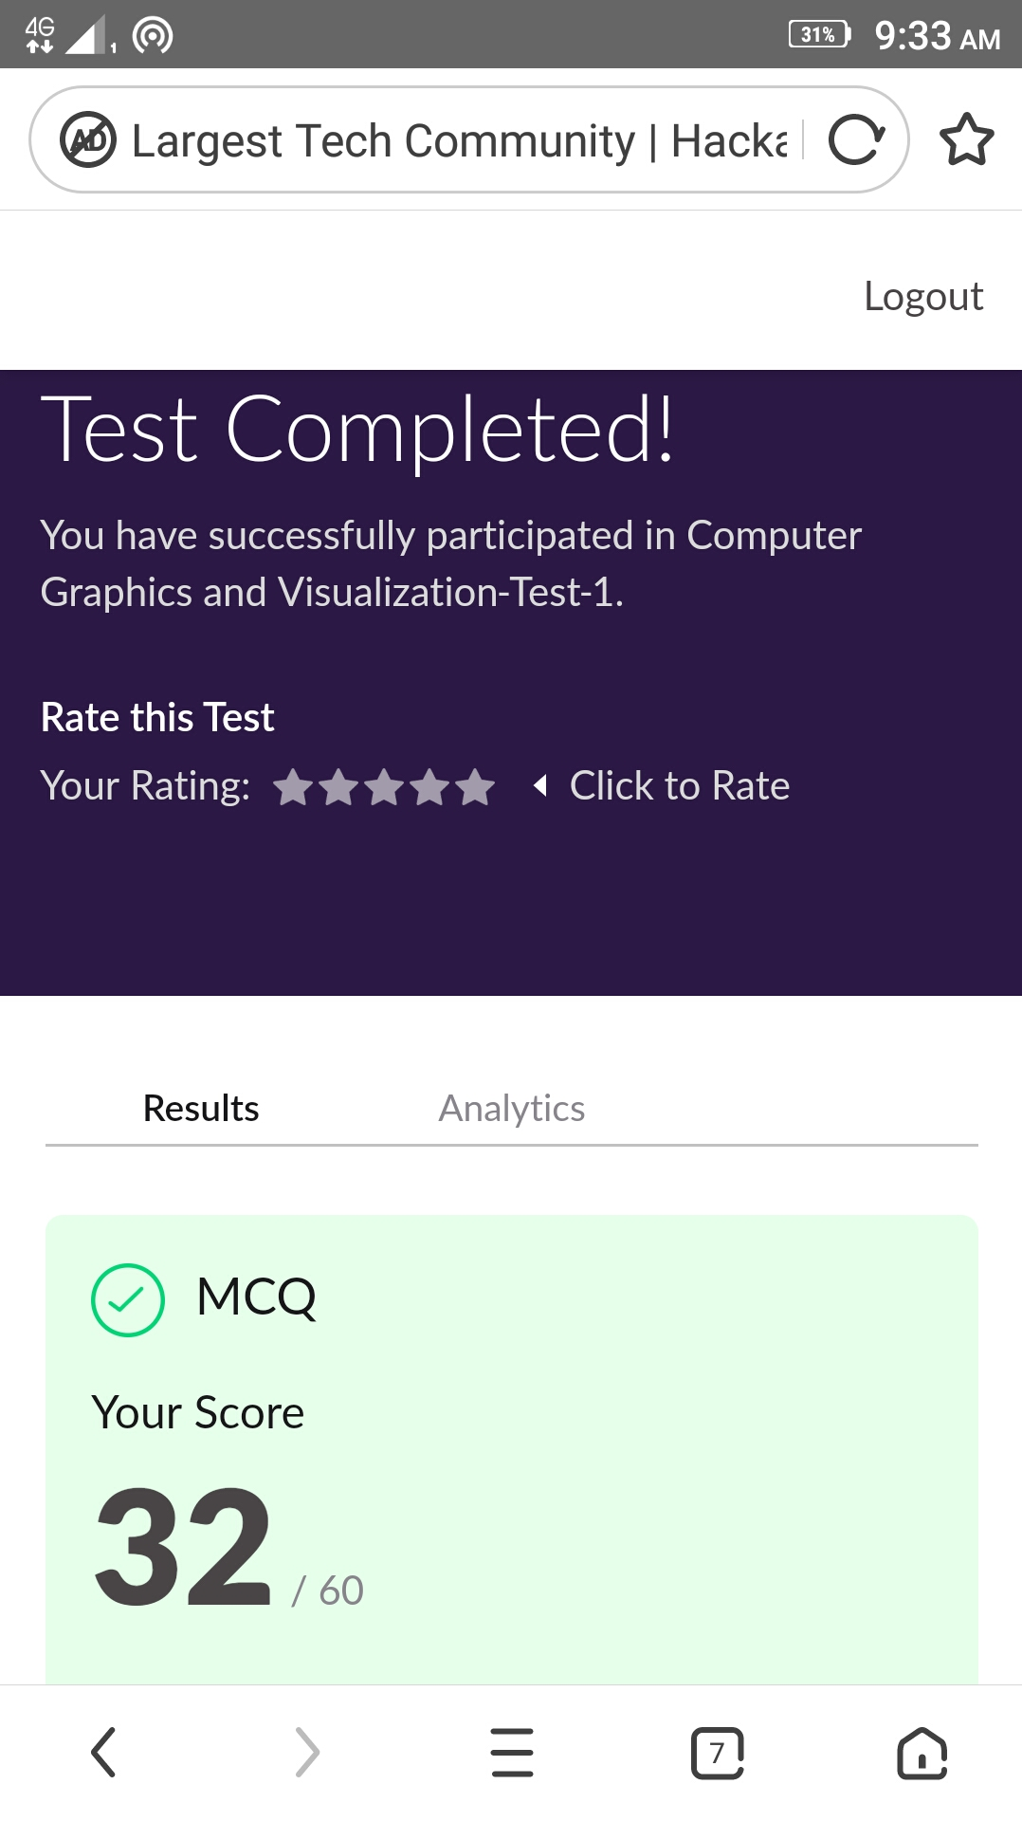

Certification Course Details: (Attach the snapshot and briefly write the report for the same)

A course on full stack developer . Its done by using language JAVA.

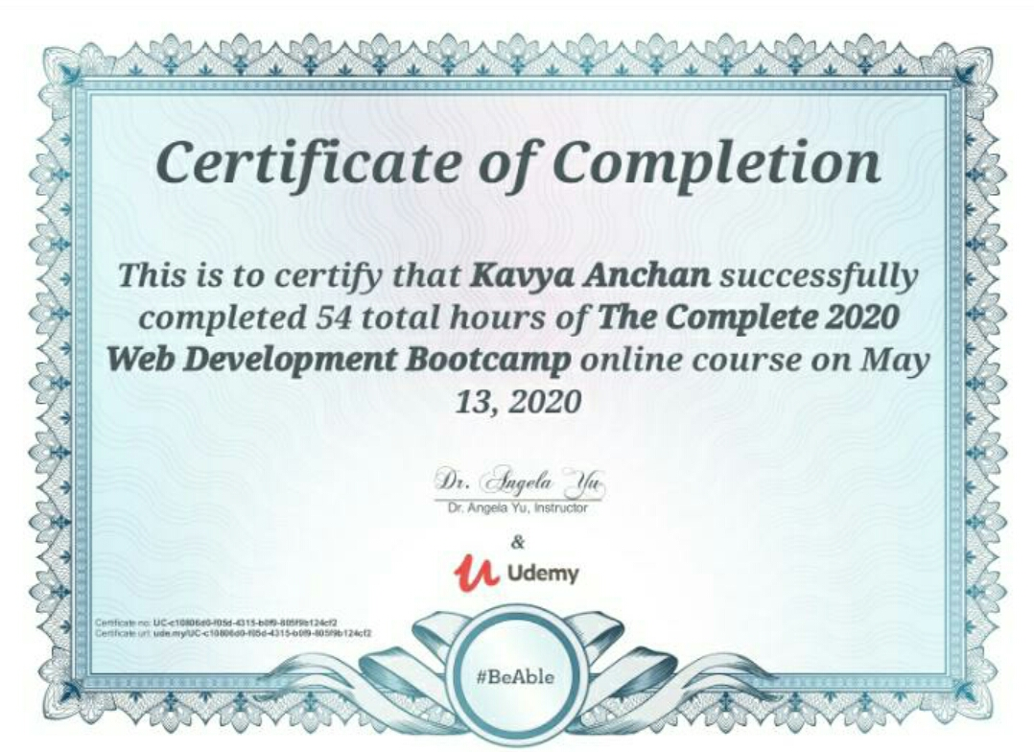

Coding Challenges Details: (Attach the snapshot and briefly write the report for the same)

Repository name: https://github.com/kavya-077/DAILY-STATUS